**Trupti Thakur**

**CMSC 203**

**Assignment 2 -Birthday Gifts**

**02/19/2020**

**Design Document**

1. **pseudoCode.**

Class Birthday

Main()

Display the welcome message.

Declare a String variable called toyChoice, name, card, balloon.

Declare a integer variable age.

Declare double Variable cost, totalCost;

Take user input for the child name and save in the variable name.

Take user input for the child age and save in the variable age.

Take user input for the child toy choice and save in the variable toyChoice.

determines age-appropriate for the toy:

plushie: 0 to 2 years

book: 4 to 7 years

blocks: 3 to 5 years

display a message if the toy is not age appropriate.

Take the user input if user wants to cancel out toy request.

if Yes

then take again user input for Name, age, toyChoice.

else

Calculate the toy cost.

Take a user Input if card or balloon should be added to the gift and save the response in card variable or balloon variable.

If yes

Add card / balloon cost in the gift cost.

Display the child name, age and the gift cost.

totalCost +=cost.

Display total amount of order and random five digit order number.

Take user input for another gift purchase.

If Yes

repeat the steps.

Else

Generate 5 digit order number for the purchase.

Display Total cost , order number and Display programmer name at the end.

2) **T**est table :

|  |  |  |  |  |  |
| --- | --- | --- | --- | --- | --- |
| **Test Case #** | **Input** |  | **Expected Output** | **Actual Output** | **Did the test pass?** |
| 1 | Name :Ani  Age= 1;  Toy = PLUSHIE  Card : no  Balloon : No  Another Gift : no |  | The gift for Ani 1 years old is plushie $25.00 | The gift for Ani 1 years old is plushie $25.00  The total cost of your order is $25.00 Order number is 15876. | pass |
| 2 | Name : Susie Smith  Age= 2;  Toy = PLUSHIE  Another toy=Y  Name : Johnny Jones  Age= 5;  Toy = blocks |  | The gift for Susie Smith 2 years old is plushie $25.00.  The gift for Johnny Jones 5 years old is blocks $20.00  The total cost of your order is $45.00 Order number is xxxxx | The gift for Susie Smith 2 years old is plushie $25.00.  The gift for Johnny Jones 5 years old is blocks $20.00  The total cost of your order is $45.00 Order number is 15376. | pass |
| 3 | Name :Jack  Age= 4;  Toy = Book  Card Y  Balloon =Y  Another Toy=N |  | The gift for Jack 4 years old is Book $23.95 | The gift for Jack 4 years old is Book $23.95  The total cost of your order is $23.95 Order number is 10874. | pass |
| 4 | Name :Joe  Age= 7;  Toy = plushie  Card=Y  Another Toy =N |  | The Toy is not age appropriate. Do you want select different Toy ?  The gift for Joe 7 years old is plushie $27.95 | The Toy is not age appropriate. Do you want select different Toy ?  The gift for Joe 7 years old is plushie $27.95  The total cost of your order is $27.95  Order number is 11876. | pass |
| 5 | Name :Brittany  Age= 3;  Toy = blocks  Another Toy=Y |  | The gift for Brittany 3 years old is blocks $15.00 | The gift for Brittany 3 years old is blocks $15.00 | pass |

Screen shots

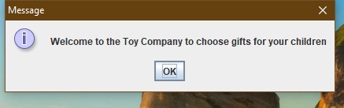

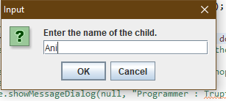

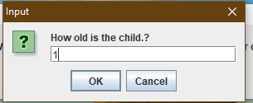

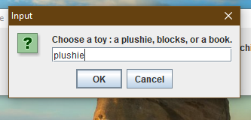

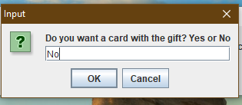

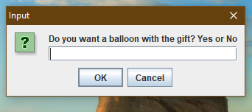

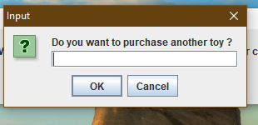

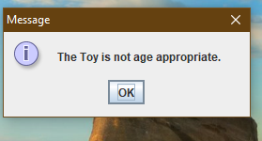

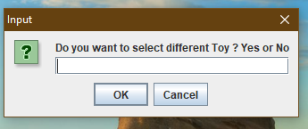

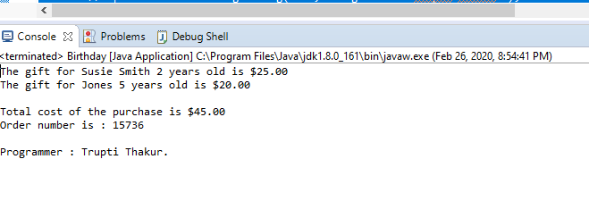

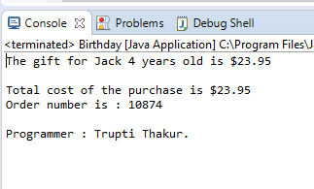

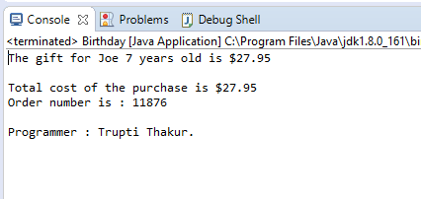

Declare and initialized constant double PLUSHIE = 25.0, BOOK = 15.0, BLOCKS = 20.0, CARD = 2.95, BALLOON = 6.0;

* determines age-appropriate for the toy:

* plushie: 0 to 2 years

* book: 4 to 7 years

* blocks: 3 to 5 years

* **@return** true if toy matches age range and false otherwise.